

Technical Updates



*from*

*June 21,2019*

***phx42 Probe Care***

43% of the units we have repaired in the past 2 months have come in with a damaged probe.

Pair the probes with specific phx42s and help Technicians learn how to care for the probes.

The best way to prevent drift failures is a weekly Probe Integrity Inspection and focused Technician training.

Attached the probe handle to the backpack when not actually monitoring so that it isn’t accidentally dropped.

Never mar or scratch the center of the Luer Lock fitting where the sealing is occurring.

If the filter breaks, follow the “Removing Broken Filters” Procedure.

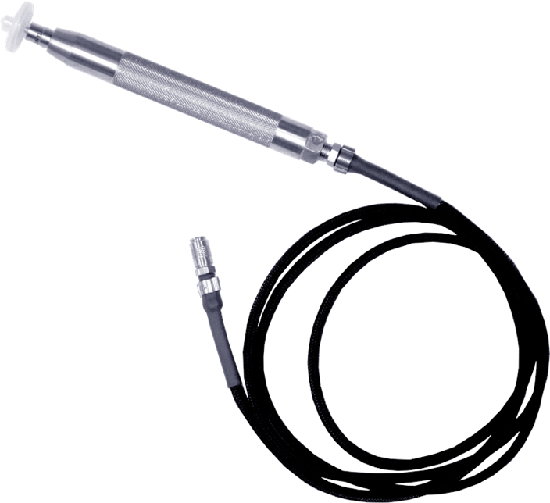

Prevent the probe hose from snagging or pulling.

Use the backpack plates provided.

Follow “phx42 Backpack Modification” procedure to ensure proper oriented in the backpack so that the probe connection is not pinched or kinked while being used.

**Current version of the phx42 user manual is available at**[**www.ldartools.com**](http://www.ldartools.com/)**> Resources.**